<https://inventwithpython.com/pygame/chapters/>

<https://inventwithpython.com/pygame/chapter4.html>

<https://inventwithpython.com/pygame/chapter5.html>

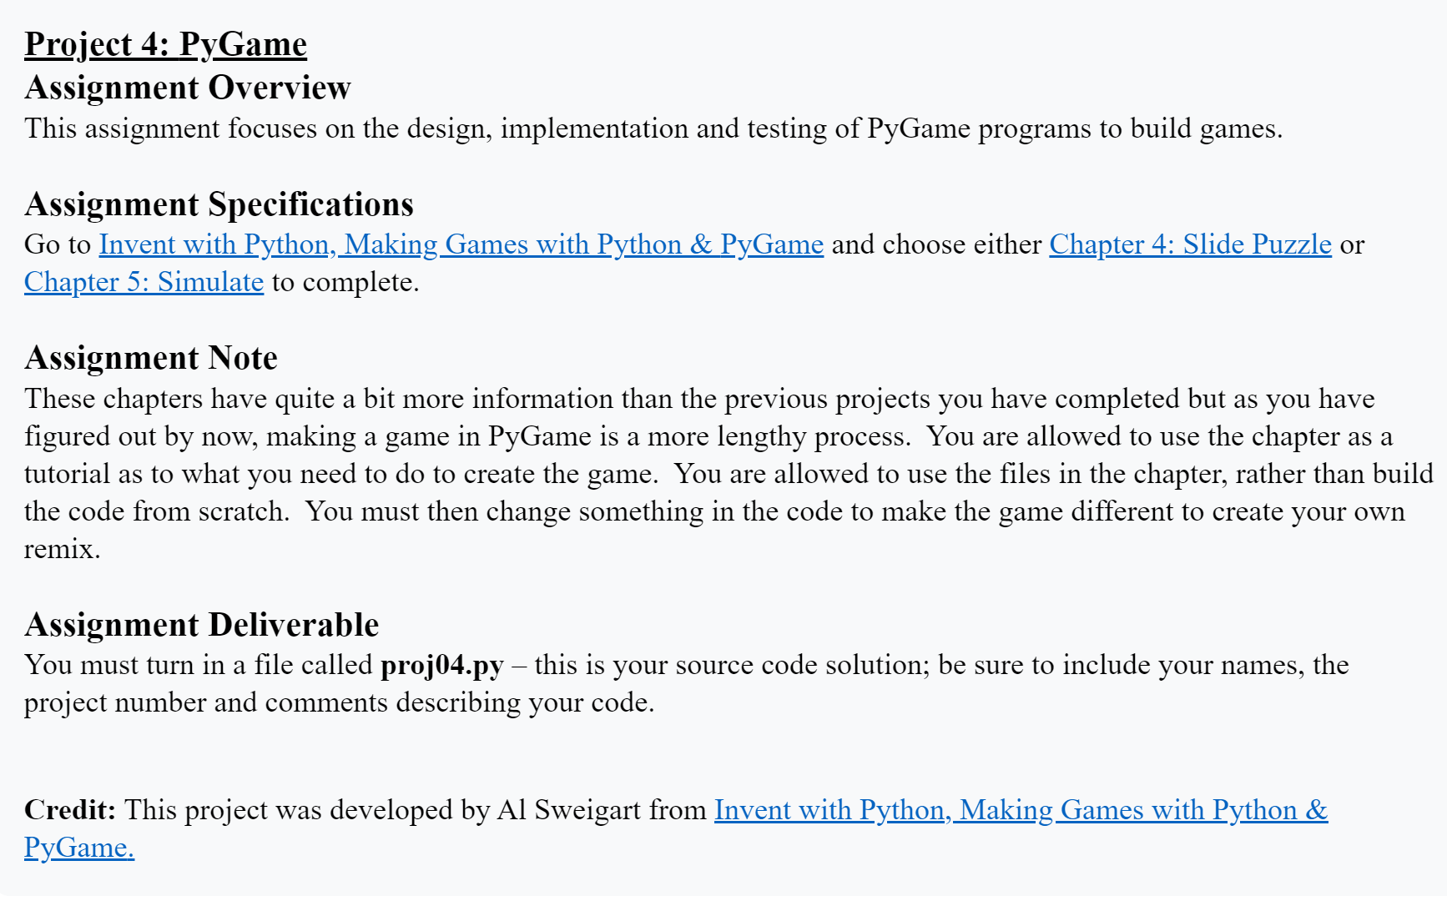

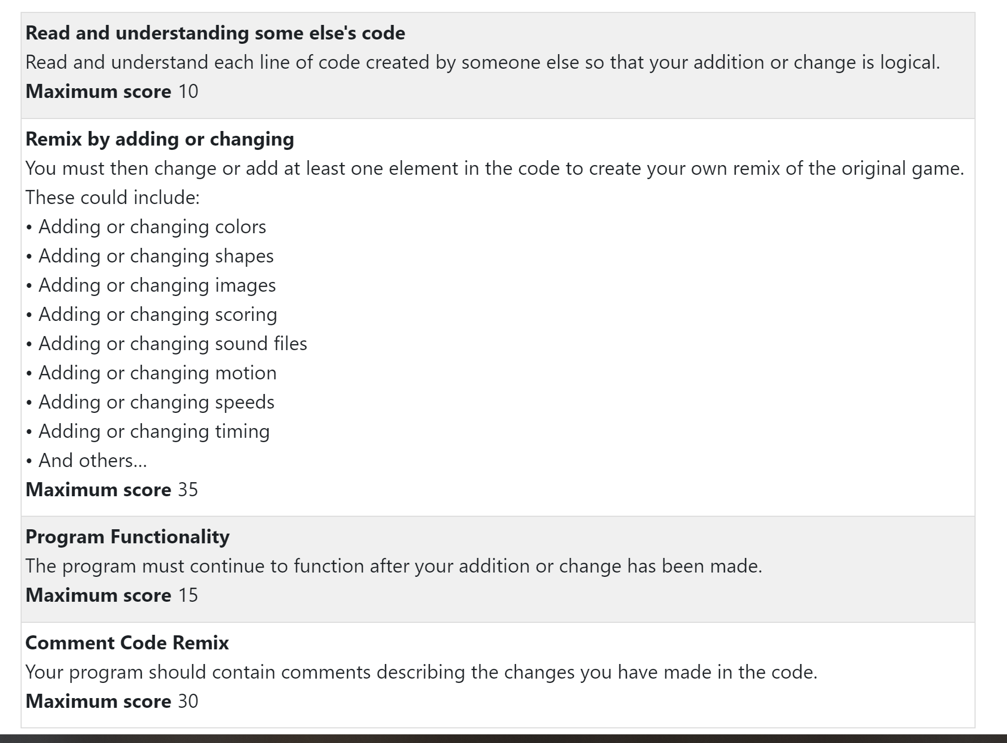

<https://www.youtube.com/watch?v=ZFo4mtLJEWs&list=PLQVvvaa0QuDdLkP8MrOXLe_rKuf6r80KO&index=3>

[](https://www.youtube.com/watch?v=ZFo4mtLJEWs&list=PLQVvvaa0QuDdLkP8MrOXLe_rKuf6r80KO&index=3)